ASSIGNMENT-4

|  |  |
| --- | --- |
| **Assignment Date** | 05 November 2022 |
| **Student Name** | Sure keerthana |
| **Student Register Number** | 111419104107 |
| **Maximum Marks** | 2 Marks |

# Question 1:

Pull an Image from docker hub and run it in docker playground.

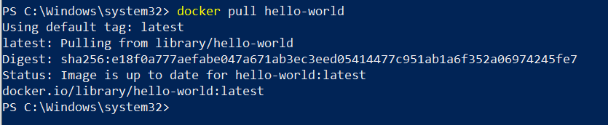

# Question 2:

Create a docker file for the job portal application and deploy it in DockerDesktop Application

FROM

helloworld:lates tWORKDIR

~/Desktop/ ADD .

helloworld/ WORKDIR

~/Desktop/htmlfile RUN pip install -r requirements RUN chmod +x app.sh

CMD ["/bi n/sh","app.sh"]

# Question 3:

Create an IBM container registry and deploy helloworld app or Job portal app.

# Question 4:

Create a Kubernetes cluster in IBM cloud and deploy helloworld image orjob portal image and also expose the same app to run in node port.

